[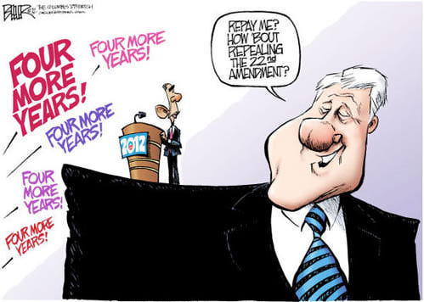](http://0.tqn.com/d/politicalhumor/1/0/W/j/4/Barack-and-Bubba.jpg)

[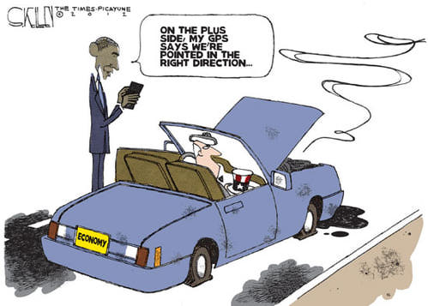](http://0.tqn.com/d/politicalhumor/1/0/q/b/4/Obama-Right-Direction.jpg)

[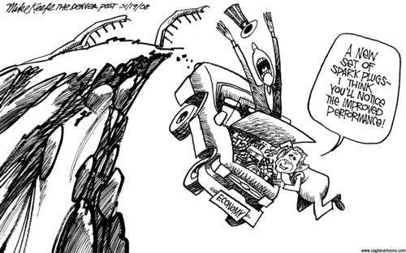](http://0.tqn.com/d/politicalhumor/1/0/o/v/1/economic_stimulus.jpg)

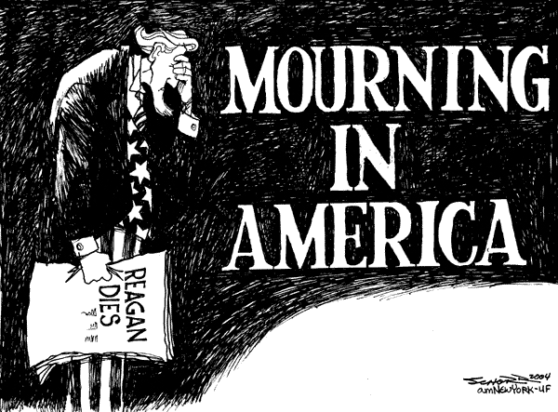

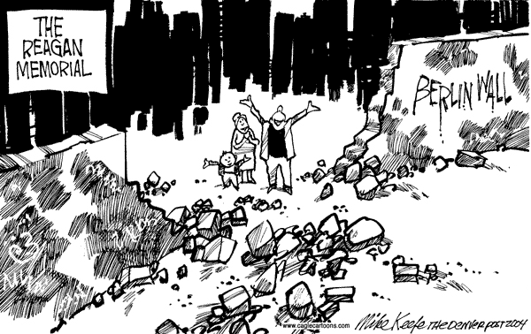[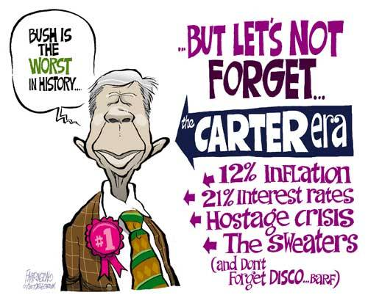](http://z.about.com/d/politicalhumor/1/0/q/i/1/carter_worst.jpg)